**Major projects**

**1.sales dashboard**:

* Sales dashboard is developed by using React.js.

**Benefits:**

* The dashboard visually displays sales information.
* Sales dashboards are useful for the company, sales teams.
* Sales dashboards provide real-time updates, This allows teams to stay current with their performance and make quick decisions.
* The dashboard includes customer details like names, lenders, contact info, and more. This info helps us understand our lenders and their interactions. My role is to qualify leads based on their lender type.
* This data helps us find out the type of lender, when they take

first initial lead , and if they've added any loans.

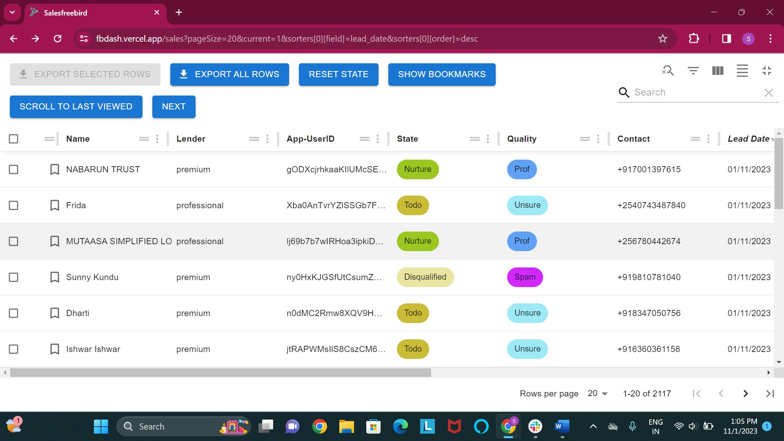

2.**sales Revenue dashboard:**

* The Sales Revenue Dashboard is a web-based application developed using the React.js framework.

**Benefits:**

* One of the main advantages of the Sales Revenue Dashboard is its ability to provide detailed insights into user subscription plans. It categorizes subscriptions into various types, allowing for a comprehensive view of the revenue generated through different plans like:
* Active trials
* Expired trials
* Total lifetime subscriptions
* Total premium monthly subscriptions
* Total team medium subscriptions etc.
* The sales revenue dashboard provides the total revenue for the month based on parameters such as Today, Yesterday, This Week, This Month, and Custom Date.

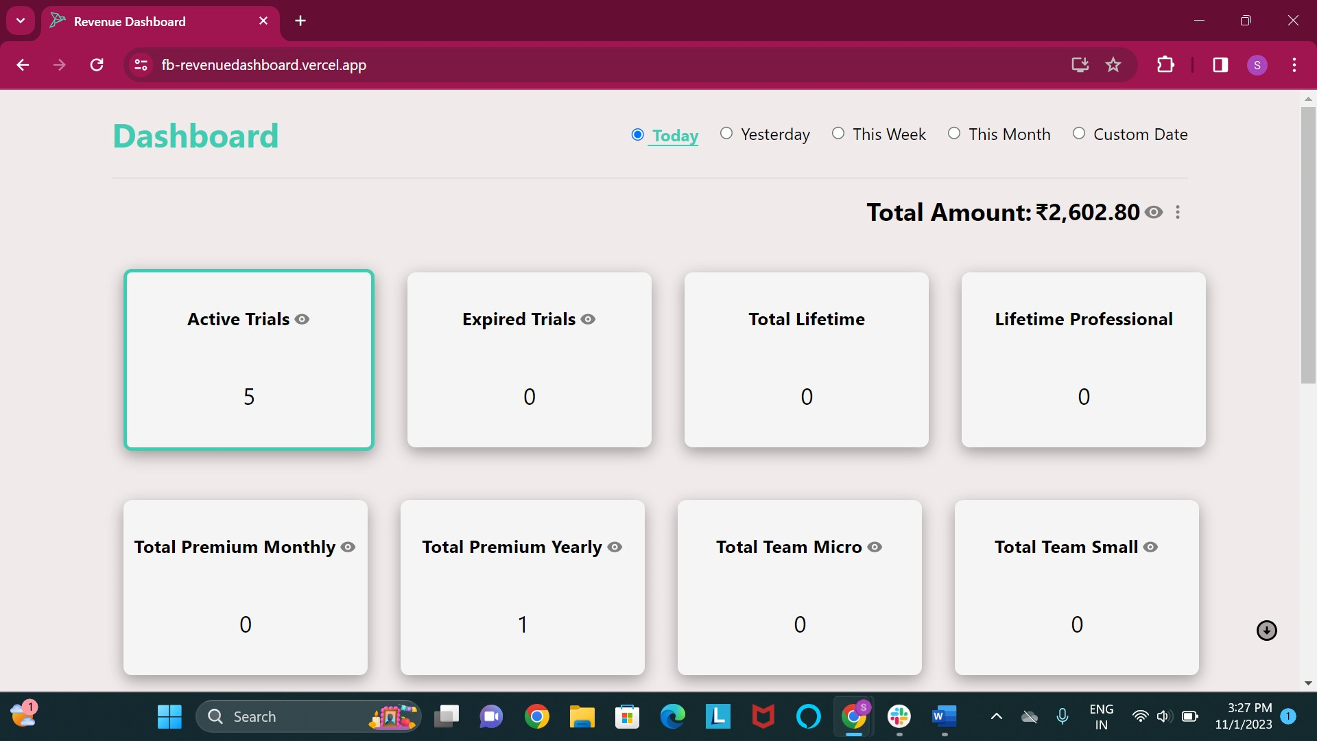

**3.Sales Analysis dashboard:**

* The Sales Analysis Dashboard project involved the development of internal tools using ReactJS and Material UI, which are popular technologies for building user interfaces.

**Benefits:**

* The dashboard is designed to analyze sales data based on the sales funnel. It categorizes the sales process into three main stages:

**Top Funnel:**

* This stage represents users who are currently engaged in active free trials of the product or service. It serves as the entry point of potential customers into the sales pipeline.

**Middle Funnel**

* In the middle funnel, valuable data about potential users is gathered and analyzed. This may include user interactions, preferences, and behavior, providing valuable insights into their level of Interest **.**

**Bottom Funnel:**

* The bottom funnel is the final stage, where users have progressed to a point where they are ready to make a purchase. These are the individuals who have shown a strong intent to subscribe or buy the product or service**.**
* By categorizing the sales process in this manner, the Sales Analysis Dashboard offers a structured and insightful view of the customer journey**.**

